ETD8A12-12-channel IO input and output controller commamd
Notice:
1 data must be HEX format
2The slave address (device address) must be consistent with the DIP switch ( A0-A5)
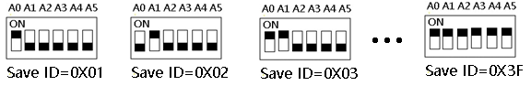
The baud rate is 9600 , 8 data bits, one stop bit, and no parity bit. Each data frame contains 8 bytes
Function code
RS485 address  (Station address)  (1) | Function (1) | Register address (2) | Read number (2) | CRC16 (2)
 | 03 Read
 | 06 Write
16(0x10)
Write multiple registers

Function code | Register address | Register content | Number of bytes | Register value | Remark
03 06  16（0x10） | 0x0000~0x000B  （1-11） | Output port status | 2 | 0x0000  0x0001 | 0x0000 Relay Close  0x0001 Relay Open
03 06  16(0X10) | 0x0070  （112） | Output port status | 2 | 0 no output  1 has output | One bit for one channel only supports opening and closing instruction. 1 open 0 close
03 | 0x0080-0x08B  (128-139) | Input port status | 2 | 0X0000  0X0001 | NPN Input  0X0000 Input Off  0X0001 Input On
 | 0X00C0  (192) | Input port status | 2 | 0：Input Off  1：Input On | 0xc0 ：12 channel
03 06  16（0x10） | 0X00F8 | Input port status automatic reporting function | 2 | Second | 0: query  1-255: Automatic reporting of 12 channel status. Unit: Second  1: Report every second  10: Report every ten seconds
03 06  16(0x10) | 0X00F9 | Automatic report selection | 2 |  | 0: selection 0x80-0x8B  1: selection 0xC0
03 06  16(0x10) | 0X00FA | Input and output relationship | 2 | 0X0000-0X0005 | 0x0000 Unrelated  0x0001 Self-locking relationship (default)  0x0002 Interlocking relationship  0x0003 Momentary relationship  0x0004 Interlocking relationship between two channels  0X0005 :Output follows input Association  Other values are the same as 0
06 | 0x00FB | Reset |  | The address can be 0xff or the current address, and use the following command to reset the current baud rate  FF 06 00 FB 00 00 ED E5
03 06  16（0x10） | 0x00FC  (252) |  | 2 | 0-1000 data return delay | Return data interval time after receiving the command (unit MS )
03 | 0x00FD |  | 2 | RS485 address | DIP switch settings
03 06  16（0x10） | 0x00FE | Baud rate | 2 | 0x0001~0x0005 | 1~5  1 : 2400  2 : 4800  3 : 9600 (default)  4 : 19200  5 : 38400  6: 57600  7:115200  8: Factory reset
03 06  16(0X10) | 0X00FF | Check bit | 2 | 0X0000-0X0002 | 0: None Parity (default)  1: Parity_Even  2: Parity_Odd  3: bits,None Parity

MODBUS 06 Command (Control command ,HEX):
Bytes Number | 1 | 2 | 3 | 4 | 5 | 6 | 7 | 8
MODBUS Definitions | Slave ID | Function | Address |  | Data |  | CRC Check
Function | Device Address | Function | Channel number |  | Command | Delay time | CRC Check
Open | 0x00-0x3F | 0x06 | 0x0000-  0x000B |  | 0x01 | 0x00 | 2Bytes CRC
Close | 0x00-0x3F | 0x06 | 0x0000-  0x000B |  | 0x02 | 0x00 | 2Bytes CRC
Toggle (Self-locking) | 0x00-0x3F | 0x06 | 0x0000-  0x000B |  | 0x03 | 0x00 | 2Bytes CRC
Latch Inter-locking) | 0x00-0x3F | 0x06 | 0x0000-  0x000B |  | 0x04 | 0x00 | 2Bytes CRC
Momentary (Non-locking) | 0x00-0x3F | 0x06 | 0x0000-  0x000B |  | 0x05 | 0x00 | 2Bytes CRC
Delay | 0x00-0x3F | 0x06 | 0x0000-  0x000B |  | 0x06 | 0x00-0xff | 2Bytes CRC
Open all | 0x00-0x3F | 0x06 | 0x0000 |  | 0x07 | 0x00 | 2Bytes CRC
Close all | 0x00-0x3F | 0x06 | 0x0000 |  | 0x08 | 0x00 | 2Bytes CRC
Interlock between two channels | 0x00-0x3F | 0x06 | 0x0001-0x000C |  | 0x09 | 0x00 | 2Bytes CRC
Remarks:
1 Momentary mode, delay time is 1 seconds
2 Delay mode, delay time is 0-255 seconds
3 0x0000-0x000B registers not only support 06 function code, but also support 16 (0X10) function code
4 Interlocking between two channels refers to interlocking of channels 1-2, 3-4, 5-6,7-8,9-10,11-12

Return command：
Command is active, return to send commands; instruction is invalid no return.

MODBUS 03 Command (Read status command ,HEX):
Bytes Number | 1 | 2 | 3 | 4 | 5 | 6 | 7 | 8
MODBUS Definitions | Slave ID | Function | Address |  | Data |  | CRC Check
Function | Device Address | Function | Starting register address |  | Register length |  | CRC Check
Read Channel 1 State | 0x00-0x3F | 0x03 | 0x0000 |  | 0x0001
Read Channel 2 State | 0x00-0x3F | 0x03 | 0x0001 |  | 0x0001
Read 2 consecutive channels status | 0x00-0x3F | 0x03 | 0x0000-0x000A |  | 0x0002
Read 3 consecutive channels status | 0x00-0x3F | 0x03 | 0x0000-0x0009 |  | 0x0003
Read all 12 channels status | 0x00-0x3F | 0x03 | 0x0000 |  | 0x000B
Read input1 status | 0x00-0x3F | 0x03 | 0x0080 |  | 0x0001
Read input2 status | 0x00-0x3F | 0x03 | 0x0081 |  | 0x0001
Read input3 status | 0x00-0x3F | 0x03 | 0x0082 |  | 0x0001
Read input4 status | 0x00-0x3F | 0x03 | 0x0083 |  | 0x0001
Read the status of 2 consecutive input ports | 0x00-0x3F | 0x03 | 0x0080-0x008A |  | 0x0002
Read the status of 3 consecutive input ports | 0x00-0x3F | 0x03 | 0x0080-0x0089 |  | 0x0003
Read 12 input port status | 0x00-0x3F | 0x03 | 0x0080 |  | 0x000B
Input and output relationship | 0x00-0x3F | 0x03 | 0x00FA |  | 0x0001
Baud rate | 0x00-0x3F | 0x03 | 0x00FE |  | 0x0001
Check bit | 0X00-0X3F | 0X03 | 0X00FF |  | 0X0001

Read status command returns (function code 03, HEX format):
Bytes length | 1 | 1 | 1 |  | 2
MODBUS Definitions | Slave ID | Function | data length | data | CRC16 Check
Function | Device Address | Function | data length | Relay state  0x0001 open  0x0000 close | CRC16 Check
Channel 1  open | 0x00-0x3F | 0x03 | 0x02 | 0x0001
Channel 1  close | 0x00-0x3F | 0x03 | 0x02 | 0x0000
Channel 2  open | 0x00-0x3F | 0x03 | 0x02 | 0x0001
Channel 2  close | 0x00-0x3F | 0x03 | 0x02 | 0x0000
Channel 1 open  Channel 2 open | 0x00-0x3F | 0x03 | 0x04 | 0x0001 0x0001
Channel 1 open  Channel 2 close | 0x00-0x3F | 0x03 | 0x04 | 0x0001 0x0000
Channel 1 close  Channel 2 open | 0x00-0x3F | 0x03 | 0x04 | 0x0000 0x0001
Channel 1 close  Channel 2 close | 0x00-0x3F | 0x03 | 0x04 | 0x0000 0x0000
Input 1 On | 0x00-0x3F | 0x03 | 0x02 | 0x0001
Input 1 Off | 0x00-0x3F | 0x03 | 0x02 | 0x0000
Input 2 On | 0x00-0x3F | 0x03 | 0x02 | 0x0001
Input 2 Off | 0x00-0x3F | 0x03 | 0x02 | 0x0000
Input 1 On  Input 2 On | 0x00-0X3F | 0x03 | 0x04 | 0x0001 0x0001
Input 1 On  Input 2 Off | 0x00-0x3F | 0x03 | 0x04 | 0x0001 0x0000
Input 1 Off  Input 2 On | 0x00-0x3F | 0x03 | 0x04 | 0x0000 0x0001
Input 1 Off  Input 2 Off | 0x00-0x3F | 0x03 | 0x04 | 0x0000 0x0000

MODBUS commands you can use "Modbus Poll" input, as shown below
（CRC check generated automatically）
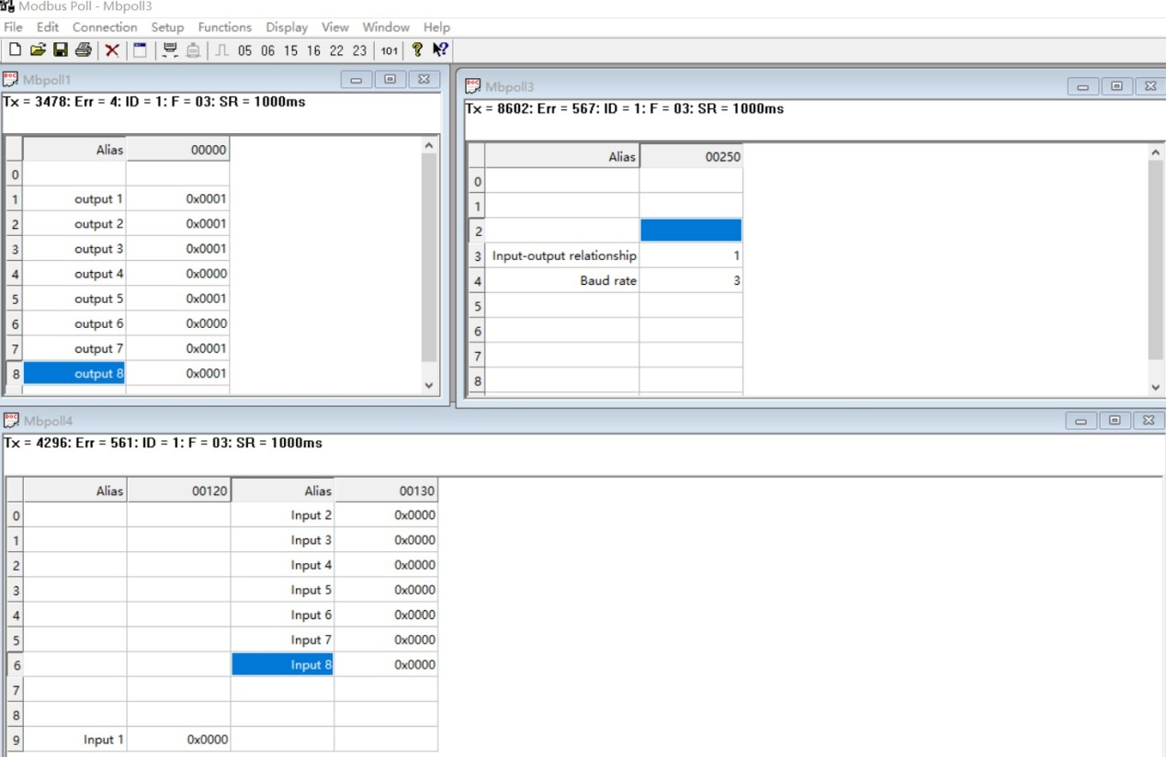
You can also use HyperTerminal serial input, as shown below
（Manually add CRC check）
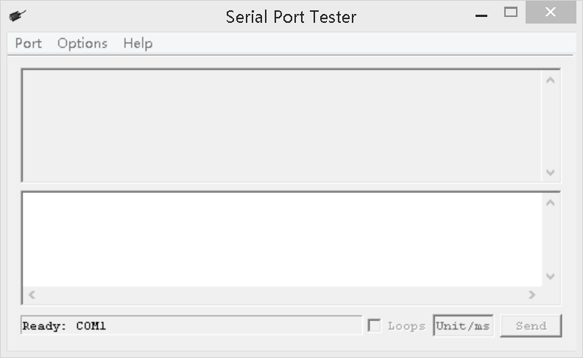

example:
Set channel 1 to open: 01 06 00 00 01 00 88 5A
Set channel 1 to close: 01 06 00 00 02 00 88 AA
Set channel 1 to self-locking mode: 01 06 00 00 03 00 89 3A
Set channel 1 to interlock mode: 01 06 00 00 04 00 8B 0A
Set channel 1 to jog mode: 01 06 00 00 05 00 8A 9A
Set channel 1 to delay 10S : 01 06 00 00 06 0A 0A 6D
Set channel 1 to delay 100S : 01 06 00 00 06 64 8B 81
Interlock between channels 1-2: 01 06 00 00 09 00 8F 9A (open 1 close 2)

Set channel 2 to open: 01 06 00 01 01 00 D9 9A
Set channel 2 to close: 01 06 00 01 02 00 D9 6A
Set channel 2 to self-locking mode: 01 06 00 01 03 00 D8 FA
Set channel 2 to interlock mode: 01 06 00 01 04 00 DA CA
Set channel 2 to jog mode: 01 06 00 01 05 00 DB 5A
Set channel 2 to delay 16S : 01 06 00 01 06 10 DA 66
Set channel 2 to delay 60S : 01 06 00 01 06 3C DB BB
Interlock between channels 1-2: 01 06 00 01 09 00 DE 5A (open 2 close 1)

Open all channels: 01 06 00 00 07 00 8B FA
Close all channels: 01 06 00 00 08 00 8E 0A

16 (0X10) function code (only supports 0x0001-0x000C registers)
Open all：01 10 00 00 00 0C 18 01 00 01 00 01 00 01 00 01 00 01 00 01 00 01 00 01 00 01 00 01 00 01 00 DE 8D
Close Channels1-4：01 10 00 00 00 04 08 02 00 02 00 02 00 02 00 36 99
Close Channels 5-8：01 10 00 04 00 04 08 02 00 02 00 02 00 02 00 C7 56
Close Channels 9-12：01 10 00 08 00 04 08 02 00 02 00 02 00 02 00 D7 46

Read state (assuming that the channel 1 is open, the channel 2 is close).
Read channel 1 state ：01 03 00 00 00 01 84 0A
Return open：01 03 02 00 01 79 84

Read channel 2 state ：01 03 00 01 00 01 D5 CA
Return close：01 03 02 00 00 B8 44

Read channel 1 and channel 2 state ：01 03 00 00 00 02 C4 0B
Return channel open and channel 2 close ：01 03 04 00 01 00 00 AB F3

Read 1-12 channel input status：01 03 00 80 00 0C 44 27
Return all input channels OFF：01 03 18 00 00 00 00 00 00 00 00 00 00 00 00 00 00 00 00 00 00 00 00 00 00 00 00 6C F4
Return input channel 1 ON：01 03 18 00 01 00 00 00 00 00 00 00 00 00 00 00 00 00 00 00 00 00 00 00 00 00 00 A1 68

- Read baud rate
Send data
RS485 address  (Station address)  (1) | Function (1) | Register address (2) | Read number (2) | CRC16(2)

Returns data
RS485 address  (Station address)  (1) | Function (1) | Number of bytes (1) | data (n) | CRC16(2)

Function code 0x03
Register address：0x003F
Read number：0x0001
For example:
send data(RS485 address is 1)：01 03 00 FE 00 01 E5 FA
Returns data：01 03 02 00 03 F8 45
01 RS485 address，03 Function，02 length，F8 45 crc16
03 means the current baud rate is 9600bps
Baud rate corresponds to the number: 0: 1200 1: 2400 2: 4800 3: 9600 4: 19200
5:38400 6:57600 7:115200
- Write baud rate
Send data
RS485 address  (Station address)  (1) | Function (1) | Register address (2) | Setting Content (2) | CRC16(2)

Returns data
RS485 address  (Station address)  (1) | Function (1) | Register address  (2) | Register value (2) | CRC16(2)

Function code 0x06
Register address：0x003F
Setting Content：2Bytes(0-7)

For example, Change the baud rate to 4800bps:
send data(RS485 address is 1)：01 06 00 FE 00 02 69 FB
Returns data：01 06 00 FE 00 02 69 FB
Baud rate corresponds to the number: 0: 1200 1: 2400 2: 4800 3: 9600 4: 19200
5:38400 6:57600 7: 115200 8: Factory reset
Note: 1 The baud rate will be updated when the module is powered up again!
2 The factory setting can be restored when the baud rate corresponding to the number is 8. For example: 01 06 00 FE 00 08 E9 FC

- Read input and output relation register
Send data
RS485 address  (Station address)  (1) | Function (1) | Register address (2) | Read number (2) | CRC16(2)

Returns data
RS485 address  (Station address)  (1) | Function (1) | Number of bytes (1) | data (n) | CRC16(2)

Function code 0x03
Register address：0x00FA
Read number：0x0001
For example:
send data(RS485 address is 1)：01 03 00 FA 00 01 A4 3B
Returns data：01 03 02 00 01 79 84
01 RS485 address，03 Function，02 length，79 84 crc16
Register corresponding value:
0x0000 Unrelated
0x0001 Self-locking relationship (default)
0x0002 Interlocking relationship
0x0003 Momentary relationship
0x0004 Interlocking association between two channels
0X0005 Interlock between two channels
Other values are the same as 0
- Write input and output relation register
Send data
RS485 address  (Station address)  (1) | Function (1) | Register address (2) | Setting Content (2) | CRC16(2)

Returns data
RS485 address  (Station address)  (1) | Function (1) | Register address  (2) | Register value (2) | CRC16(2)

Function code 0x06
Register address：0x00FA
Setting Content：2Bytes(0-5)

For example, Set the input and output to be unrelated, and change the register value to 0X0000:
Send data(RS485 address is 1)：01 06 00 FA 00 00 A9 FB
Returns data：01 06 00 FA 00 00 A9 FB

Register corresponding value:
0x0000 Unrelated
0x0001 Self-locking relationship (default)
0x0002 Interlocking relationship
0x0003 Momentary relationship
0x0004 Interlocking association between two channels
0X0005 Output follows input Association
Other values are the same as 0
- READ Check bit
Send data
RS485 address  (Station address)  (1) | Function (1) | Register address (2) | Read number (2) | CRC16(2)

Returns data
RS485 address  (Station address)  (1) | Function (1) | Number of bytes (1) | data (n) | CRC16(2)

Function code 0x03
Register address：0x00FF
Read number：0x0001
For example:
send data(RS485 address is 1)：01 03 00 FF 00 01 B4 3A
Returns data：01 03 02 00 00 B8 44
01 RS485 address，03 Function，00 length，B8 44 crc16
Register corresponding value:
0x0000 None Parity
0x0001 Parity_Even
0x0002 Parity_Odd
0X0003 None Parity

- Write Check bit
Send data
RS485 address  (Station address)  (1) | Function (1) | Register address (2) | Setting Content (2) | CRC16(2)

Returns data
RS485 address  (Station address)  (1) | Function (1) | Register address  (2) | Register value (2) | CRC16(2)

Function code 0x06
Register address：0x00FF
Setting Content：2Bytes(0-2)

For example, Set the parity bit to even parity:
Send data(RS485 address is 1)：01 06 00 FF 00 01 78 3A
Returns data：01 06 00 FF 00 01 78 3A

Register corresponding value:
0x0000 None Parity
0x0001 Parity_Even
0x0002 Parity_Odd
0X0003 None Parity
Note: The Check bit will be updated when the module is powered up again!

- READ delay time
Send data
RS485 address  (Station address)  (1) | Function (1) | Register address (2) | Read number (2) | CRC16(2)

Returns data
RS485 address  (Station address)  (1) | Function (1) | Number of bytes (1) | data (n) | CRC16(2)

Function code 0x03
Register address：0x00FC
Read number：0x0001
E.g:
Send frame (address is 1 ): 01 03 00 FC 00 01 44 3A
Return frame: 01 03 02 00 0A 38 43
01 address code, 03 function code, 02 length, 10 means the current delay is 10*40=400ms , B9 88 is the CRC16 check code
- Set the delay time
Send data
RS485 address  (Station address)  (1) | Function (1) | Register address (2) | Setting Content (2) | CRC16(2)

Returns data
RS485 address  (Station address)  (1) | Function (1) | Register address  (2) | Register value (2) | CRC16(2)

Function code 0x06
Register address：0x00FC
Setting Content：2Bytes(0-2)

For example, Set the delay time 400ms:
Send data(RS485 address is 1)：01 06 00 FC 00 0A C9 FD
Returns data：01 06 00 FC 00 0A C9 FD
Note:1 The maximum delay is 1000ms;
2 Values exceeding 0x19 are reset to 0x00.

- Output port control (bit operation)
Send data
RS485 address  (Station address)  (1) | Function (1) | Register address (2) | Read number (2) | CRC16(2)

Returns data
RS485 address  (Station address)  (1) | Function (1) | Number of bytes (1) | data (n) | CRC16(2)

Function code 0x03
Register address：0x0070 corresponds to channel 1-12 output port status
Read number：0x0001
For example, read the status of 1-12 channels output port
Send frame: (address is 1 ): 01 03 00 70 00 01 85 D1
Return frame: 01 03 02 07 75 7B 93
01 address code, 03 function code, 02 length; 07 75 refers to the output port status, the 1、3、5、6、7、9、10、11 bits are 1 , and the other bits are 0 . So channels1、3、5、6、7、9、10、11 are open, and the other channels are closed.

- Write output port status (bit)
Send data
RS485 address  (Station address)  (1) | Function (1) | Register address (2) | Setting Content (2) | CRC16(2)

Returns data
RS485 address  (Station address)  (1) | Function (1) | Register address  (2) | Register value (2) | CRC16(2)

Function code 0x06
Register address：0x0070
Setting Content：2Bytes
For example, open channels 1 , 2 , and 3 , and close other channels
Send frame (address is 1 ): 01 06 00 70 00 07 C9 D3
Return frame: 01 06 00 70 00 07 C9 D3
Address code 01 , function code 06 , 00 70 refers to the registers of channels 1-12 ; 0007 refers to channels 1-3 open, and channels 4-12 close.

For example, open all channels
Send frame (address is 1 ): 01 06 00 70 0F FF CD A1
Return frame: 01 06 00 70 0F FF CD A1
Address code 01 , function code 06 , 00 70 refers to the register of channel 1-12 ; 0FFF refers to channel 1-12 open.

- READ Input port status automatic reporting function
Send data
RS485 address  (Station address)  (1) | Function (1) | Register address (2) | Read number (2) | CRC16(2)
Returns data
RS485 address  (Station address)  (1) | Function (1) | Number of bytes (1) | data (n) | CRC16(2)

Function code 0x03
Register address：0XF8
Read number：0x0001
For example, READ Input port status automatic reporting function
Send frame: (address is 1 ): 01 03 00 F8 00 01 05 FB
Return frame: 01 03 02 00 00 B8 44
01 address code, 03 function code, 02 length; 00 00 indicates that it is now the default state and will not be reported automatically.
0x0001-0x00FF indicates the automatic reporting time.

- SET Input port status automatic reporting function
Send data
RS485 address  (Station address)  (1) | Function (1) | Register address (2) | Setting Content (2) | CRC16(2)

Returns data
RS485 address  (Station address)  (1) | Function (1) | Register address  (2) | Register value (2) | CRC16(2)

Function code 0x06
Register address：0x00F8
Setting Content：2Bytes
Send frame (address is 1 ): 01 06 00 F8 00 05 C8 38
Return frame: 01 06 00 F8 00 05 C8 38
00 05 :Automatic report every 5 seconds

- READ Automatic report selection
Send data
RS485 address  (Station address)  (1) | Function (1) | Register address (2) | Read number (2) | CRC16(2)
Returns data
RS485 address  (Station address)  (1) | Function (1) | Number of bytes (1) | data (n) | CRC16(2)

Function code 0x03
Register address：0XF9
Read number：0x0001
For example, READ Automatic report selection
Send frame: (address is 1 ): 01 03 00 F9 00 01 54 3B
Return frame: 01 03 02 00 00 B8 44
01 address code, 03 function code, 02 length;
00 00 select 0x0080-0x008b register 0x0001-0x00FF indicates the automatic
00 01 select 0x00C0 register

- SET Automatic report selection
Send data
RS485 address  (Station address)  (1) | Function (1) | Register address (2) | Setting Content (2) | CRC16(2)

Returns data
RS485 address  (Station address)  (1) | Function (1) | Register address  (2) | Register value (2) | CRC16(2)

Function code 0x06
Register address：0x00F9
Setting Content：2Bytes
Send frame (address is 1 ): 01 06 00 F9 00 01 98 3B
Return frame: 01 06 00 F9 00 01 98 3B
00 01 : select 0x00c0 register to report automatically

- Restore factory
Send data
RS485 address  (Station address)  (1) | Function (1) | Register address (2) | Setting Content (2) | CRC16(2)

Returns data
RS485 address  (Station address)  (1) | Function (1) | Register address  (2) | Register value (2) | CRC16(2)

RS485 address 0XFF
Function code 0x06
Register address：0x00FB
Setting Content：2Bytes
Send frame (address is 1 ): FF 06 00 FB 00 00 ED E5
Return frame: FF 06 00 FB 00 00 ED E5
- Read address
Send data
RS485 address  (Station address)  (1) | Function (1) | Register address (2) | Read number (2) | CRC16(2)
Returns data
RS485 address  (Station address)  (1) | Function (1) | Number of bytes (1) | data (n) | CRC16(2)

address 0XFF
Function code 0x03
Register address：0XFD
Read number：0x0001
For example,
Send frame: FF 03 00 FD 00 01 00 24
Return frame: FF 03 02 00 01 50 50

